**FabMo beta hardware Start-Up Instructions**

Welcome to the beta version of FabMo. We're glad you're ready to give it a try. Please be aware that these are still the early stages. Many FabMo features are not yet functional and others exist in example form rather than final polished versions. But most of the basic functionality is ready to go and we expect you will be as excited as we are about this new digital-fab platform.

A particular inconvenience at the moment is that managing the network connections (and potential updates) will need to be done manually using a command-line interface to the Intel Edison single board computer (SBC). We describe this process below, but for the moment we'll just get you going with a direct (access point) connection to give the platform a try.

Also, note that this beta version does not yet have user-management functions or log-on security in place – this actually makes testing a bit easier. Before long there will be a fully developed system to manage users of each FabMo device.

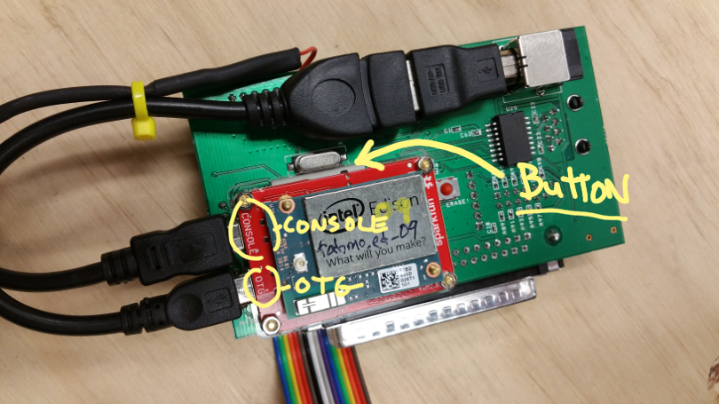

Back side of FabMo Control Card showing Edison mount and connection. Note “Button” used to re-start in AP mode.

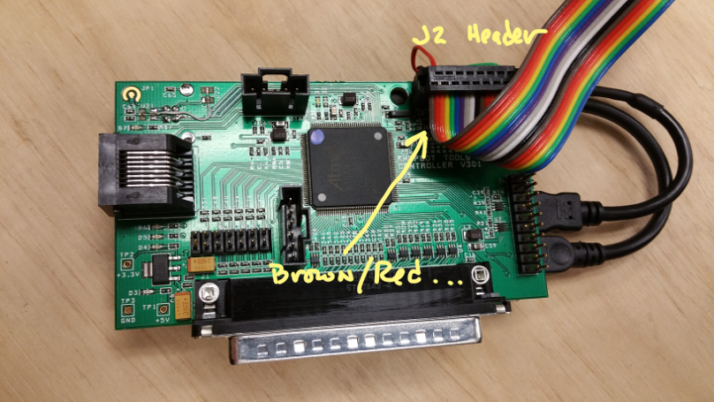

Front side of FabMo Control Card showing header-cable connection orientation.

**Plugging in the Hardware**

STANDARD: If using FabMo with a Handibot, ShopBot, or from a ShopBot Interface (developer) Board:  The FabMo Control Card unit is ready to plug into the 37-pin-D-connector on your interface board. For existing tools, the FabMo Control Card simply replaces your current ShopBot Control Card. Plug the FabMo card into the interface board on your tool, then attach the ribbon-cable header. The header on the ribbon cable plugs into the header connector the same way as the cable removed with the ShopBot Control Card. Specifically, the connector mates with the appropriately-pinned header connector in the middle of the board. The cable will exit down toward the 37-pin-D-connector (the brown-red end goes at the #1 end of the connector).

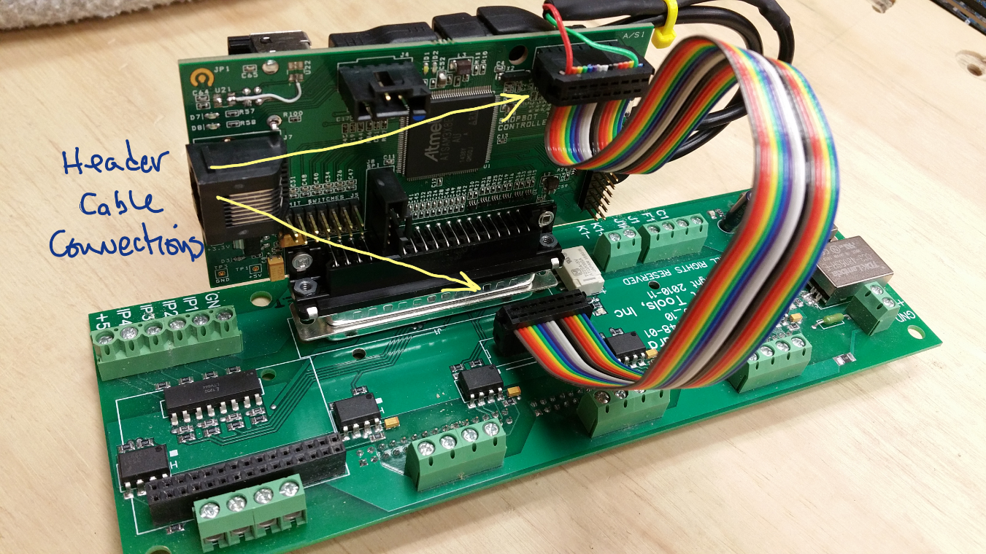

Control Card mounted on ShopBot development board (similar to Desktop and Handibot). Note cable orientation.

SIMULATOR: If using FabMo as a Stand-alone FabMo Simulator (special Simulator Cable Required):  The FabMo Control Card is normally powered by (isolated) power from the interface board it is attached to. So to use the Card as a stand-alone simulator to explore the look and feel of FabMo, you will need to swap-in a simulator cable that powers the FabMo Card from a USB power source (USB power supply or computer USB port). To connect a Simulator Cable, disconnect the short micro-USB connector attached to the "Console" port of the Edison adaptor on the back of the FabMo Card and remove the attached header from the front of the Card. Plug the micro-USB connector of the Simulator Cable into the "Console" port and attach the header connector to the front of the Card, the red wire side goes towards pin 1 on the J2 header.

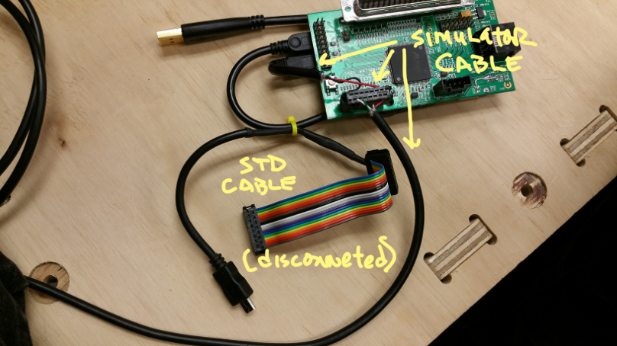

Connection of “simulator” cable.

**Running FabMo**

Your FabMo beta system can be accessed via Wi-Fi in either, "Access Point Mode" or "Station Mode (network)". Access Point (AP) Mode will be your fallback mode and FabMo arrives setup to boot in Access Point mode, so let’s give Access Point a try:

     1 - Power up your FabMo beta, either by turning on the tool or power supply (or by plugging in the USB cable to power on PC or charger, if you are running the board as a simulator). You should see a blue light around the Edison and 2 reds and a green on the face of the control card, with a blue “heartbeat” pulsing at about 3 seconds.

     2 - Allow a minute for FabMo to set up its access point

     3 - Then, use the Wi-Fi manager on your PC, your tablet, or your smartphone or other device to identify FabMo. It will show up as an available network named "fabmo_ed_##" [Marked on your FabMo Unit]. Log in as you would any Wi-Fi network. [Use the password we have attached or provided] (once connected you are essentially on a private network, just you and your FabMo; this network will not have an internet connection).

     4 – Now, open a browser (best with Chrome or FireFox) on your device; finally, enter the IP address for FabMo in Access Point Mode:  192.168.42.1:9876

     5 - This will open the FabMo Dashboard ... (FabMo is a “responsive” app and will re-arrange to best fit your device)

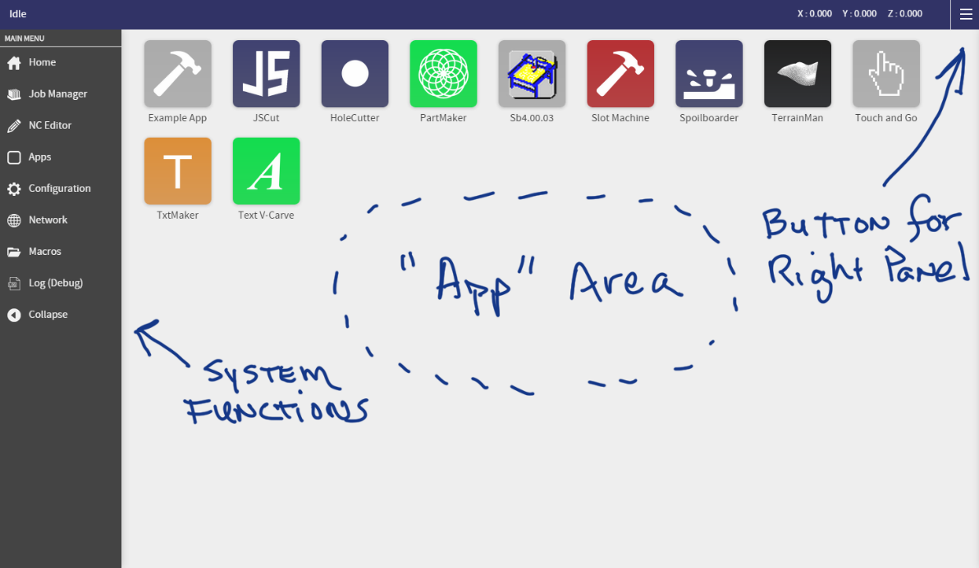

Initial FabMo screen. Note “App area”, system tools on the left, and button for right-panel slide out.

**Exploring the FabMo Dashboard**

If you managed to get everything hooked up correctly and entered the FabMo IP in your browser, you should get a main screen that looks like the image above. The “look” will vary depending on screen size and whether you are on a mobile device or not. But the functionalities are all the same. Note that there are **basic tools** in the menu on the left (most work; but do not click on the network one yet). The tool configuration for this first beta version is a Handibot. You can fuss around with the configuration tool to modify things like your Unit Values for different tools.

There are a number of **sample apps**. Some of these do interesting stuff … some are not yet really complete. They mostly represent our putterings and attempts at creating a wide range of app-programming examples. You will find the “touch and go” app is fun … we leave you to explore the rest. The Sb4 app is still pretty un-developed and only marginally functional. It will eventually be a ShopBot look-alike for those who are most comfortable with the legacy ShopBot interface.

Right away you will want to take a look at the **DRO and Handwheel Panel** which slides in from the right when you click the upper right “hamburger” icon.

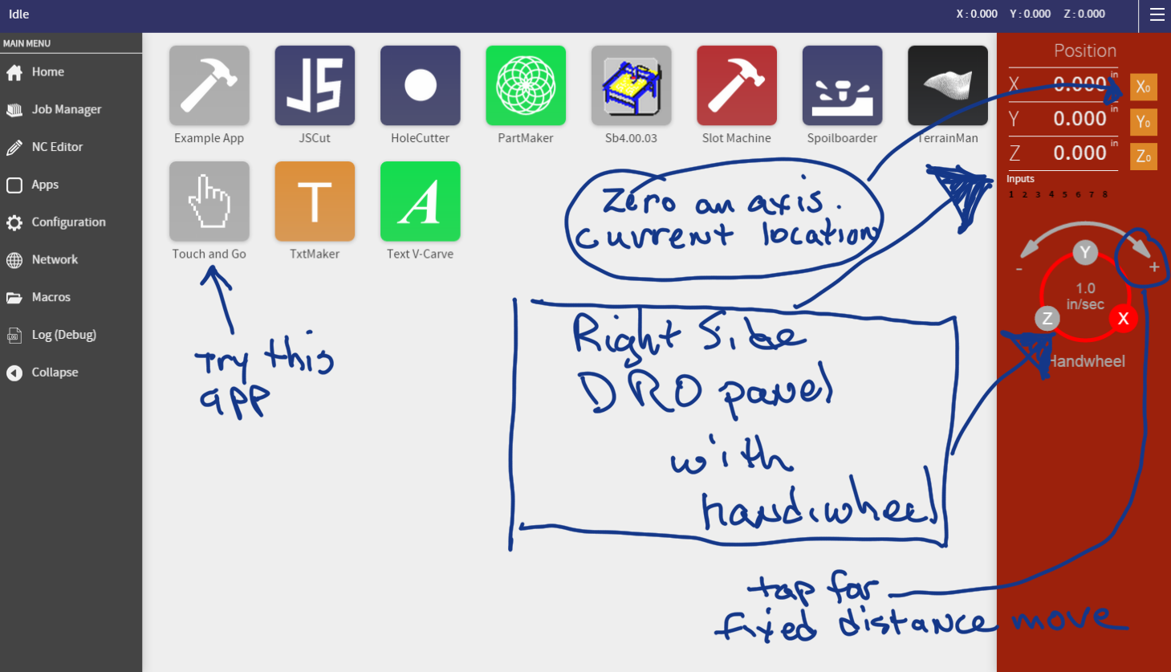

The DRO and Hand-wheel Panel has been slid out.

In the upper right of this red panel (yes, we are trying to maintain a little continuity with the legacy version) you will find a DRO with the current location of the tool (current location is also in the top bar, so the DRO panel is not a necessity for this info). The **orange buttons** to the right of the axis location will change the current location to 0 in that axis. This is like a [ZX] or [ZY], etc.

This panel also has a Handwheel. The **Handwheel (handiwheel?) is for moving your tool** around in any axis and replaces the Keypad. We hope it is self-explanatory. Crank one way or the other after putting your finger or mouse down on an axis dot (handle). Change speed by touching or clicking the center of the wheel. Make small fixed movements by clicking on one end or the other of the direction arrows at the top after touching the dot for the axis you want.

The **Job Manager** in the left panel is your primary tool for running Jobs (Part Files). It allows you to “Submit” a Job from any location your device can access and “Preview” or “Run” it. This is similar to the [FP] function of Sb3. [Because you are currently connected in AP mode, you do not have access to files on your network or in the cloud. After we get you on the network, below, you will have access to it all.] Once a file appears in your pending list, it is on your tool (Edison) and no further transfer or streaming from a device is required. Once the file is running, you can even turn off your device or change your browser to a different site, no PC or device is required after the file starts. Logging back on will bring you back up to date with what is going on.

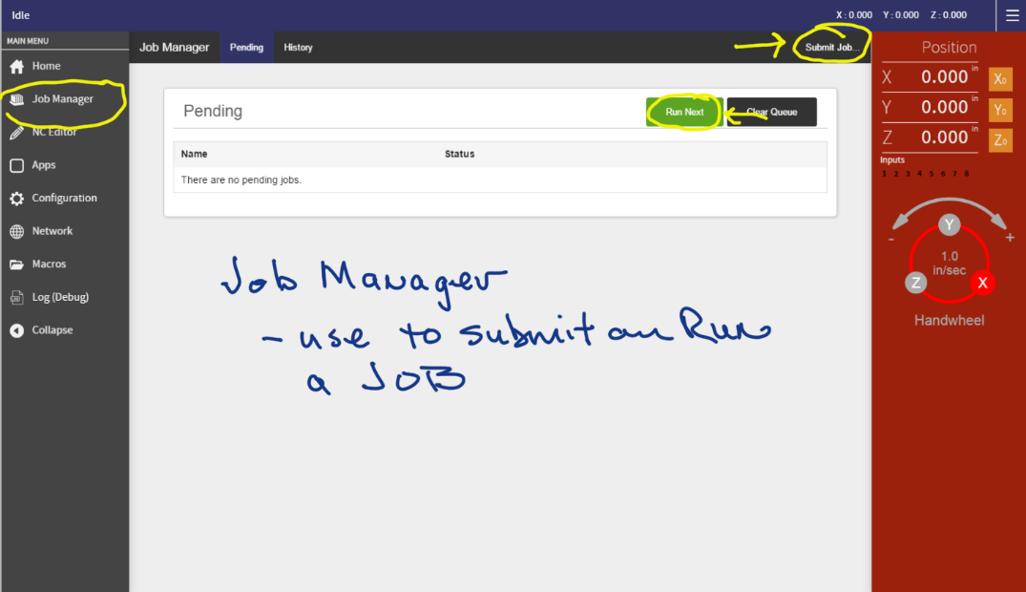

The job manager retains your files in a history that allows resubmitting, previewing, or editing.

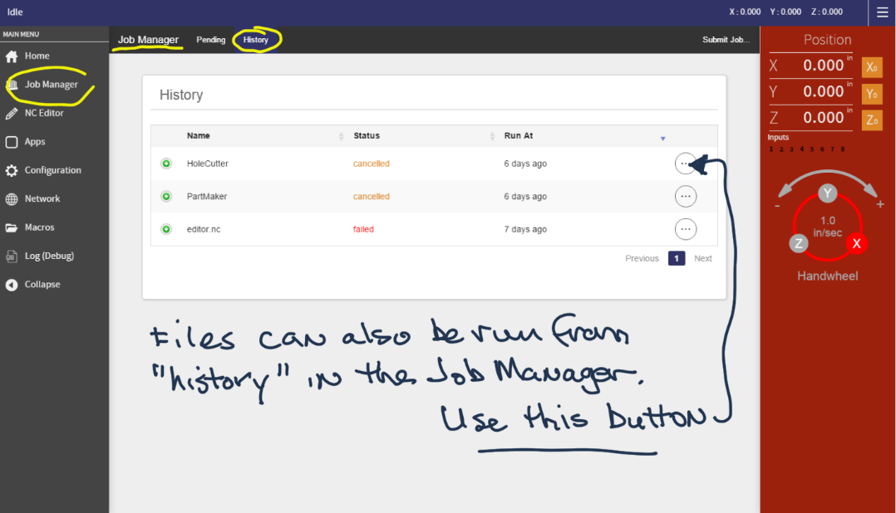

**Creating FabMo Apps**

Within the sample apps there is one special app. It is called “Example App” and provides an annotated example of how an app is created with a little HTML and javascript. You can use this file as a template to start your own project (easiest to download it from the FabMo GitHub site, where you will increasingly find other helpful info). See the Apps function on the left-side system panel for installing and deleting apps.

The most recent version of our various sample apps are available on the FabMo GitHub site. To install one, use the Apps function from the system panel to delete the current version of the app, then install the new one by selecting the .fma file for the app from GitHub. The .fma file is a compressed file that contains all the sub-files needed for an application. FabMo takes care of extracting the needed resources from these files.

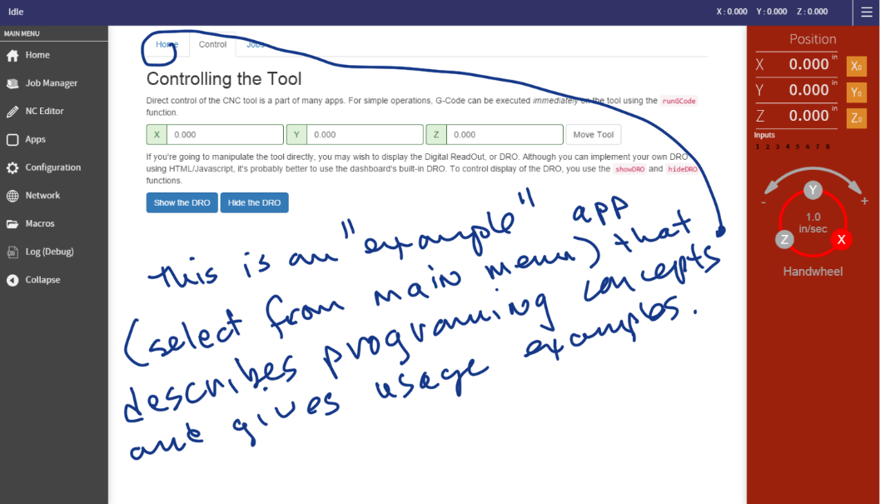

All of the apps available currently are examples of what we call “Utility Apps”, apps that are generally useful for digital fab tasks you want to with your tool and want to use repeatedly.

We also look forward to evolving a category of Design Apps, that would typically be made available from the cloud (e.g. from the Handibot Project Gallery). Some of these Design Apps will simply provide access to fixed designs. But the most interesting will offer parametric modifications to generic models followed by the unique generation of toolpaths that are then downloaded to a tool.

**APPENDIX 1 ============================================================**

**Current Techniques for Managing and Updating FabMo**

**{These methods are about to become automated … the methods are just a stand-in, but you’ll get to learn a little about working with the Edison SBC this way.}**

To interact with the FabMo software and manage things on the Intel Edison SBC, you will need to use an SSH terminal program and enter instructions via the Linux command line of the Edison. In case you are not familiar with these methods, they are introduced here.

Working with the Edison Command Line (Linux).

The most straightforward way for you to work with the Edison will be to download and install on a Windows PC, the SSH terminal emulation program, PuTTY (similar emulators are available for Mac and Linux, as well as portable devices). {Note … if you took your PC off the network to logon to your FabMo, you will need to switch back to your normal internet connection for this download.}

Get PuTTY at   [<http://the.earth.li/~sgtatham/putty/latest/x86/putty.exe>].

So … download and install PuTTY (or something similar).

Now, to put your FabMo system onto a network.

Re-logon to your PC or device via the Access Point (AP) connection with the Edison. Then start PuTTY to talk to the Edison. (You do not need to start the FabMo Dashboard for this …). Here’s how:

1. In the main session window of PuTTY, select SSH as the connection type and then enter the IP address of your FabMo in AP mode: 192.168.42.1
2. (you can save this session with a name for later use ... say, AP_FabMo)
3. Then click “Open”. You will typically get a warning message the first time you connect (because you are providing a new key); answer Yes to this warning in order to Continue ...  and you will find yourself at a "login as:" and blinking cursor in a small terminal window (you may need to hit Enter once).
4. Log in as:  root    with the password that we have provided [same as above]

You are now talking to the Edison (in linux).

To switch to Station Mode and join your local network, type the line below and hit Enter:

============================================================================

configure_edison --stationMode

============================================================================

You will then be prompted for the name (SSID) of your network and its passphrase. Just respond to the prompts, at the end of which you will be disconnected from the Access Point connection  ... the Edison will go off the air to connect to your local network. (Just close the PuTTY terminal window and put your computer or device back on your local network.)

You are now ready to connect to FabMo on your network. Here we have a little bit of a challenge. In order to make this connection, you will need to know the IP address that has been assigned to this FabMo-Edison on your network so that you can enter it in your browser. There are a number of ways to get the address. We’ve included two “locator” programs. One that runs on a PC and one that runs on and Android device. If you have the “Fing” app running on your smart-phone, this is an easy way to identify your Edison. The Edison will show up under its name along with its current IP address.

Once you know your IP address, working with FabMo on a network is the most convenient way to use it, but it is nice to be able to fall back on AP mode when needed and to work with FabMo on a jobsite, away from any networks. So …

** To revert to AP mode, hold down the little button on the red board for 6 seconds (the “Button” in indicated in the first image above; it has a distinct feel when it is clicked).

Updating FabMo.

To update to the latest version of FabMo (which is maintained on the FabMo GitHub site), you need to re-connect to the Edison in a new PuTTY or terminal session. This time, we will be connecting via the local network you just sent the Edison too – which presumably has internet access. As above, in order to make this connection you need to know the IP address that your network has assigned your Edison. This will be the same one that you found in the step above, assuming you are on the same network and your Edison has not recently been assigned a new IP. {If for some reason FabMo is no longer starting and running, the locator programs will not work and will need to use a tool like Fing to identify the Edison on your network.}

Once you have established the new terminal session. Enter the following commands, one line at a time, waiting for processing to finish between lines. The “npm install” step will take several minutes to run.

============================================================================

systemctl stop fabmo

cd /fabmo

rm -rf ./node_modules

rm -rf /opt/fabmo/approot

git pull origin master

npm install

(repeat npm install until it stops giving you errors, if it  
 does so the first time)

systemctl start fabmo

============================================================================

After you’ve started FabMo and wait a minute or two to let it get going, you can do a:

systemctl status fabmo

… to check and make sure that everything is working right. You’ll get a number of lines describing things being loaded and a last line that will indicate: “… info: FabMo Engine listening …”

If all seems good, you can start FabMo back up in your browser or refresh … and hopefully find some great improvements and updates.

***Sometime soon, you will be able to update in the FabMo connected browser (with internet connection) by just launching the page: {FabMo IP address}xxx.xxx.xxx.xxx:9876/update.html

This might or might not work for you, depending on version, etc ************************

**APPENDIX 2 ============================================================**

**TROUBLESHOOTING**

**Not getting into Access Point Mode after button**

* Try the button again, make sure you’ve held for a 6 count
* * probably necessary to work with Edison in serial console mode

**Not joining local network with –stationMode command**

* Go back to AP mode and try entering info and starting on the network again
* Restart/repower FabMo system and look for it again
* Restart your network, repower FabMo and look again
* * probably necessary to work with Edison in serial console mode

**Problems with Updating FabMo**

* The “npm update” process can take a while; just let it run – if you get errors, run again (it takes less time)
* You may need to fully refresh your browser or cycle the power on your FabMo unit for the update to take full effect
* The update should install the most recent version of system functions but not the optional apps (see above for installing new apps)